Module 5: Database Enhancement Narrative

Erin Edmondson
Southern New Hampshire
CS-499- Computer Science Capstone
Professor Jeff Sanford
June 4th, 2026

Describe Chosen Artifact
The artifact I selected for the database enhancement category was the Grazioso Salvare dashboard that was originally developed in CS-340 Client/Server Development, which I took at the beginning of 2026. This application uses Python, MongoDB, and the Dash framework to allow users to interact with data in a dashboard. The dashboard utilizes data from the Austin Animal Center. This dataset includes information about animals such as age, breed, and location. This information was used to create a dashboard to help Grazioso Salvare find dogs that may be well-suited for certain rescue types.
Justify the Inclusion in my ePortfolio
The reason I chose this artifact is because it allowed me to demonstrate the ability to develop and enhance data-heavy applications. My future career goals revolve around being able to work with and manage data. This dashboard demonstrates my ability to become more familiar with and develop client-server communications and user-focused designs. Selecting this artifact allows me to show that I can select, upgrade, and implement tools that are more beneficial for the needs of a project.
This artifact originally utilized local MongoDB. Basic sorting capabilities based on rescue types are possible. Previously, users could search through breeds; however, their input would have to match the breed specifically. For my enhancement, I integrated MongoDB Atlas so that I could implement advanced search features that are not possible with local MongoDB. I created a fuzzy search and wildcard search. Fuzzy search allows similar results to display even if there is a typo. A wildcard search allows users to partially match a word when searching. Combined, these improve user experience by ensuring search input does not have to be exact and will still display relevant results.
Course Outcomes
I have met the course outcomes that I planned to meet with this enhancement. The outcomes met with this artifact include employing strategies for building collaborative environments that enable diverse audiences and demonstrating an ability to use well-founded and innovative techniques, skills, and tools in computing practices that deliver value and accomplish industry-specific goals. For this enhancement, I worked with tools that I was not familiar with and managed to get the results intended. This demonstrated my ability to quickly understand, adapt, and learn.
I do not have any updates to the coverage plan. With this being my last enhancement, I feel confident that I have successfully met all course outcomes. The outcome for designing, developing, and delivering professional communication was partially met during my code review. It will be fully met once my ePortfolio is finalized.
Reflection
This enhancement was the one I was most concerned about being able to accomplish. Truthfully, I worried I would end up needing to change my plans and potentially choose another artifact. I had no experience with MongoDB Atlas or deploying clusters. I was aware it was typically a paid service; however, after researching, I learned that they offer a free tier if I stay under a certain number of resources. I knew this would not be an issue due to how small the project and data is.
One of the hardest parts has been trying to figure out how to integrate it and the search features into an already existing application that was tailored to specifically be used with local MongoDB. This enhancement required a lot of testing and research. Additionally, it was difficult trying to figure out what would be the best way to send this to my professor and showcase this for my ePortfolio. This is mainly because I understand the importance of securing database credentials and controlling access to cloud-hosted databases through user permissions. When showcasing it for my ePortfolio, I am thinking I will upload it to Github and ignore the .env file, since it is what contains my connection string. Then I can include videos or screenshots in my ePortfolio and link to the GitHub repository for it.

See screenshots below to show what was implemented
The screenshot below shows the user setups. I have redacted my admin user and have created a read-only user for evaluations.
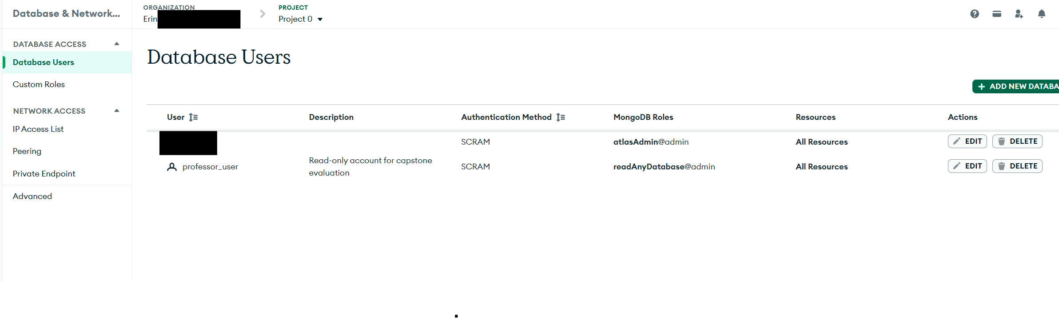

The screenshot below shows my connection through Compass.
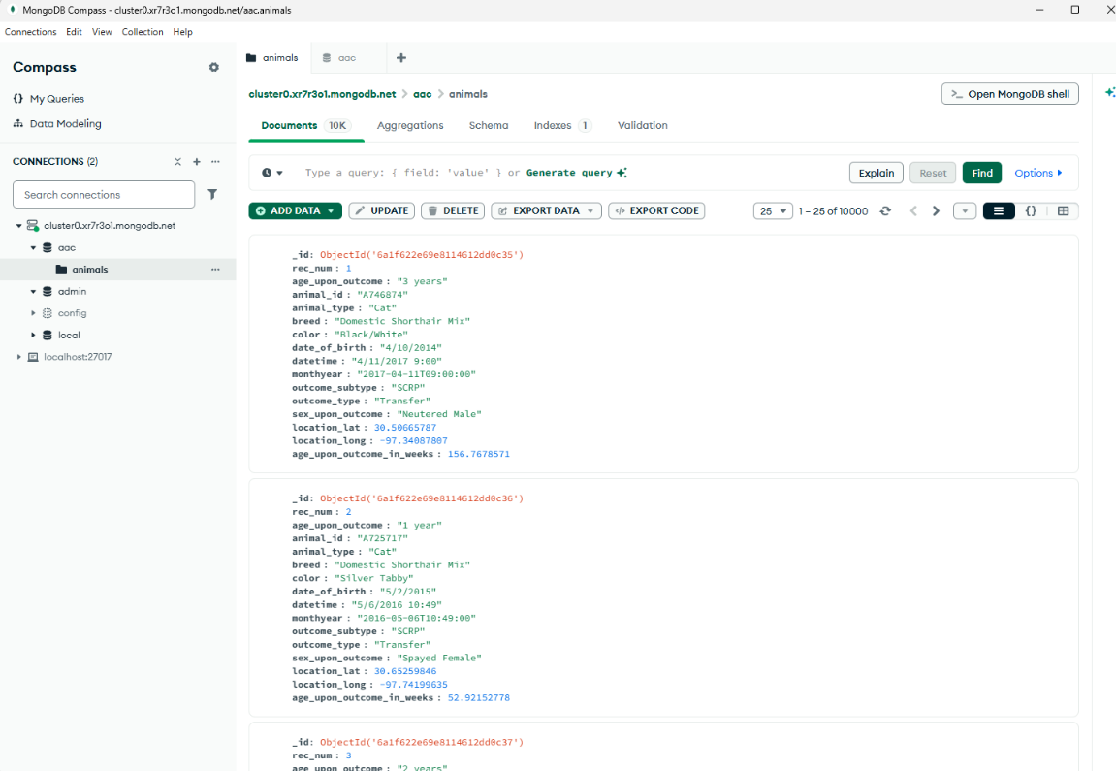
The below screenshot shows that I typed “labredor” and still found relevant results.
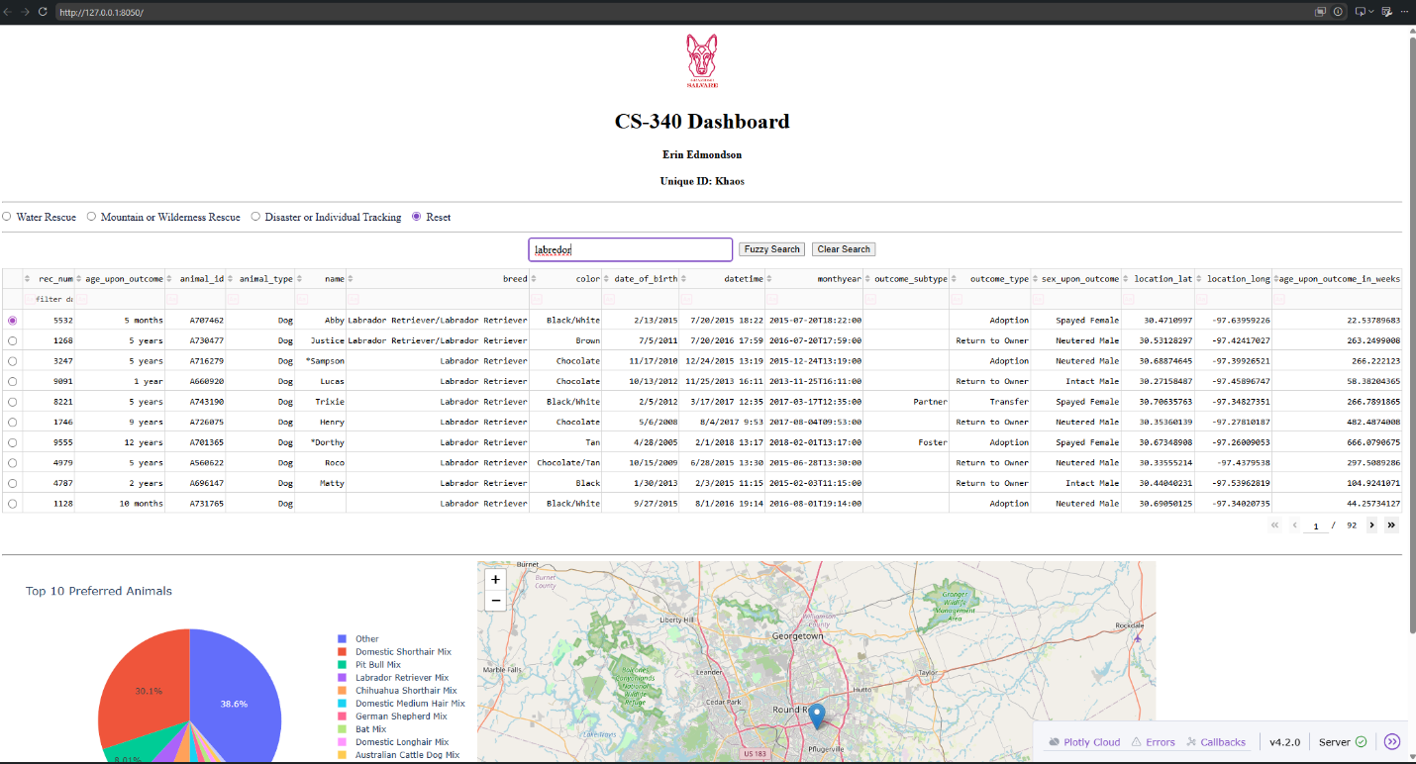

The screenshot below shows that I get relevant results when I search “pit” which is a partial match.
